**DAY 8**

**CLASS EXERCISE 1**

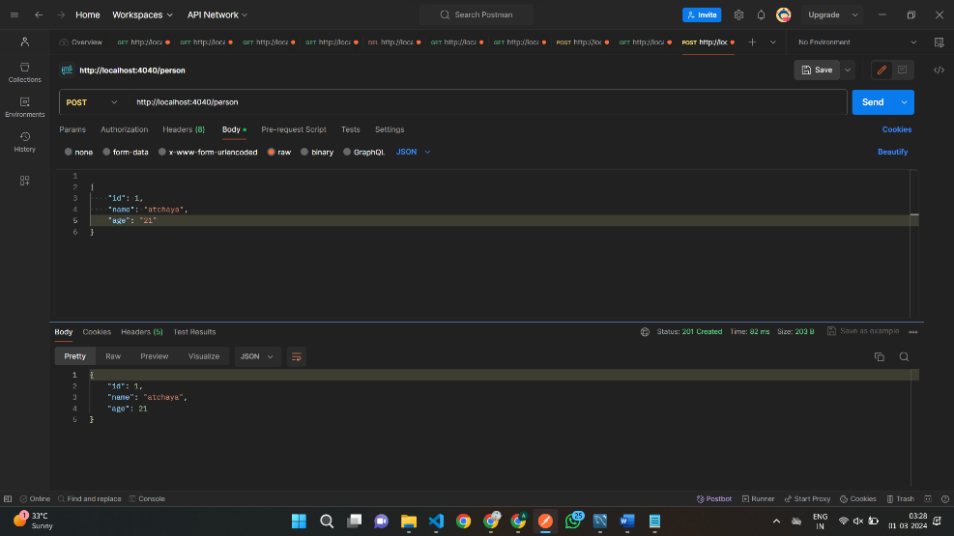POST MAPPING

**GET MAPPING BY STARTS BY NAME**

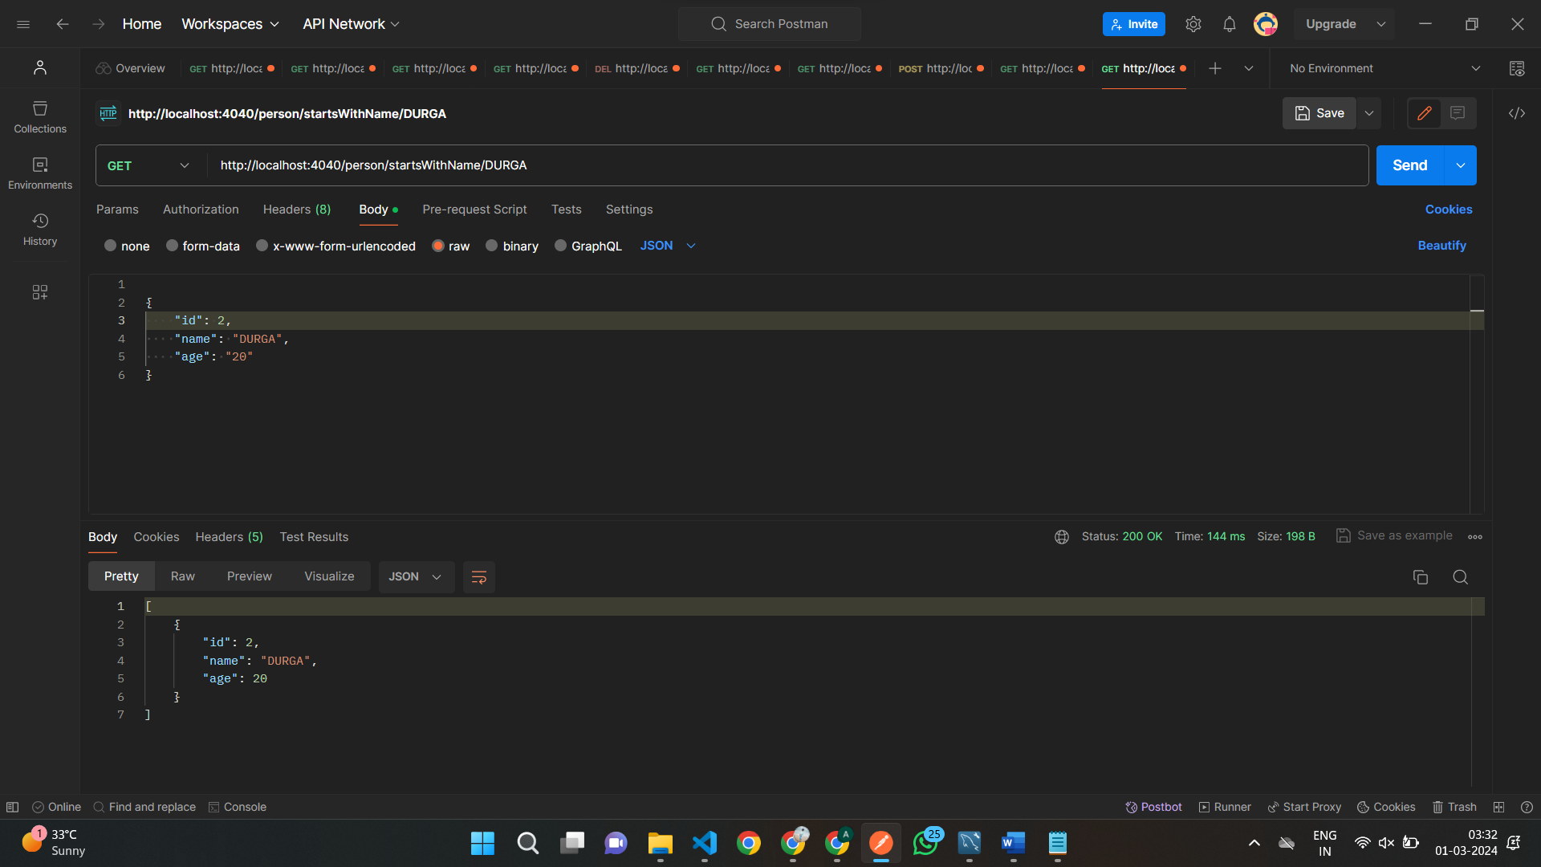

**GET MAPPING BY ENDS WITH NAME**

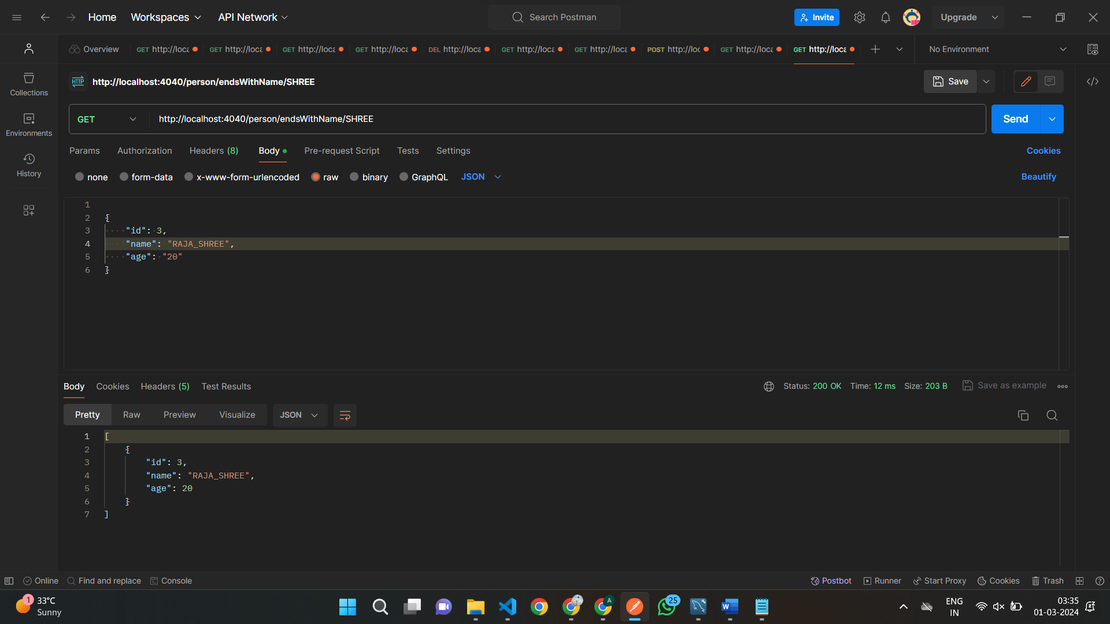

**EXERCISE 2**

**Post mapping**

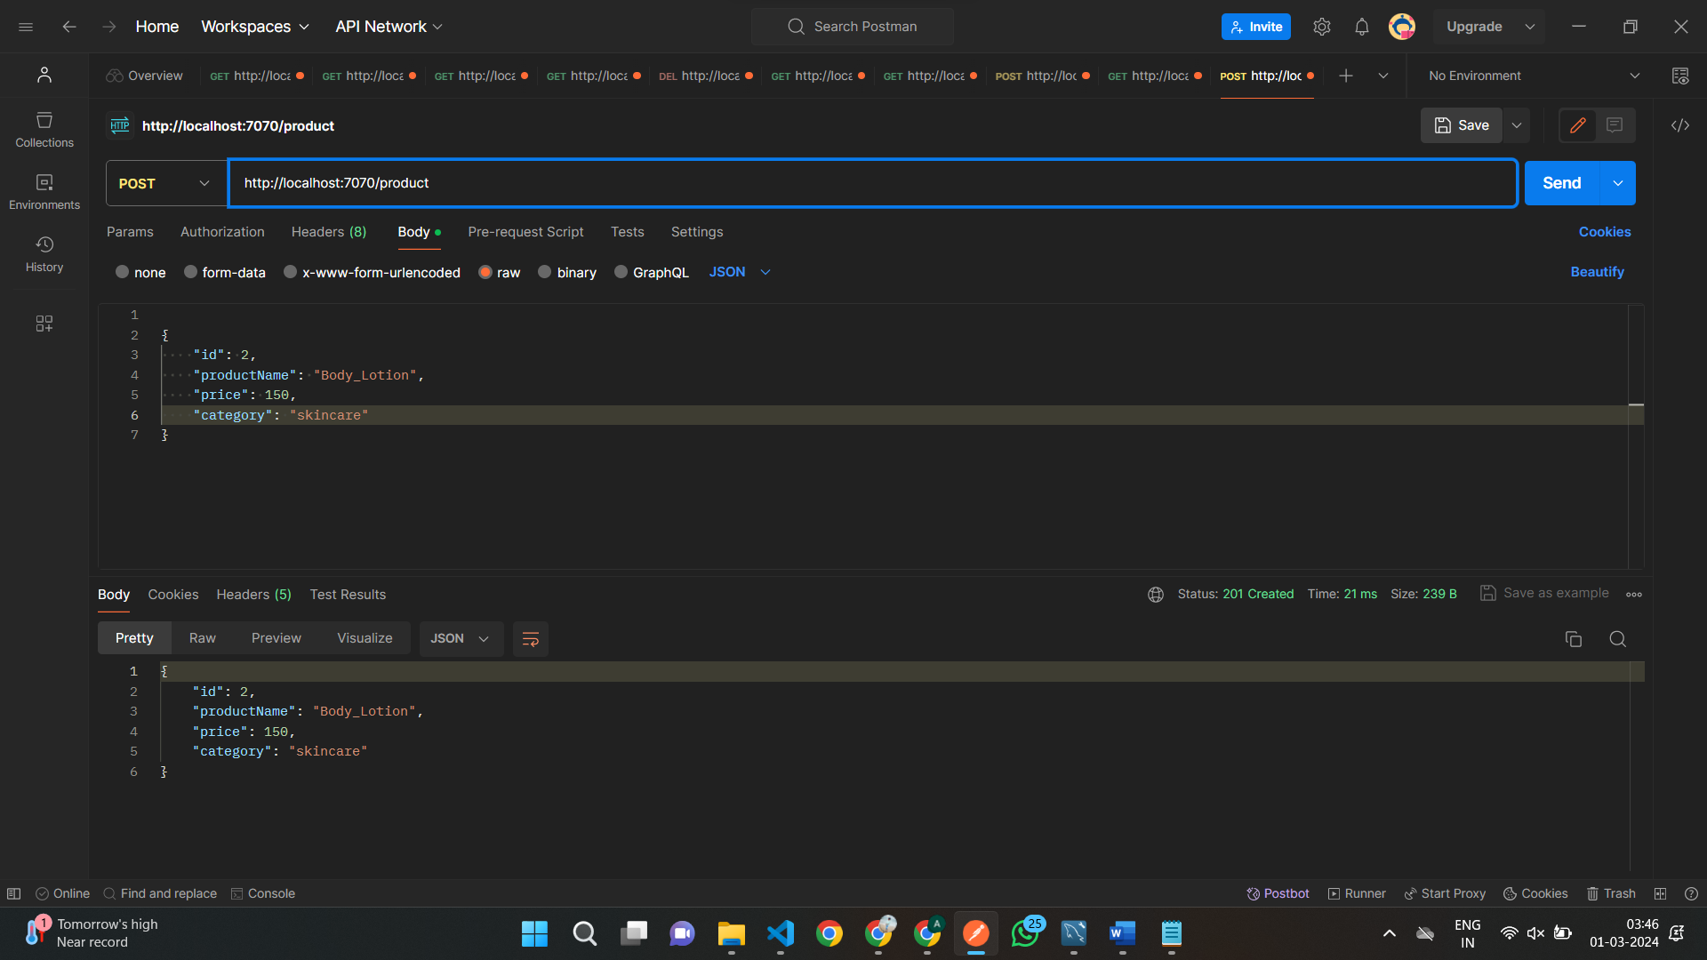

**Get mapping by starts with name**

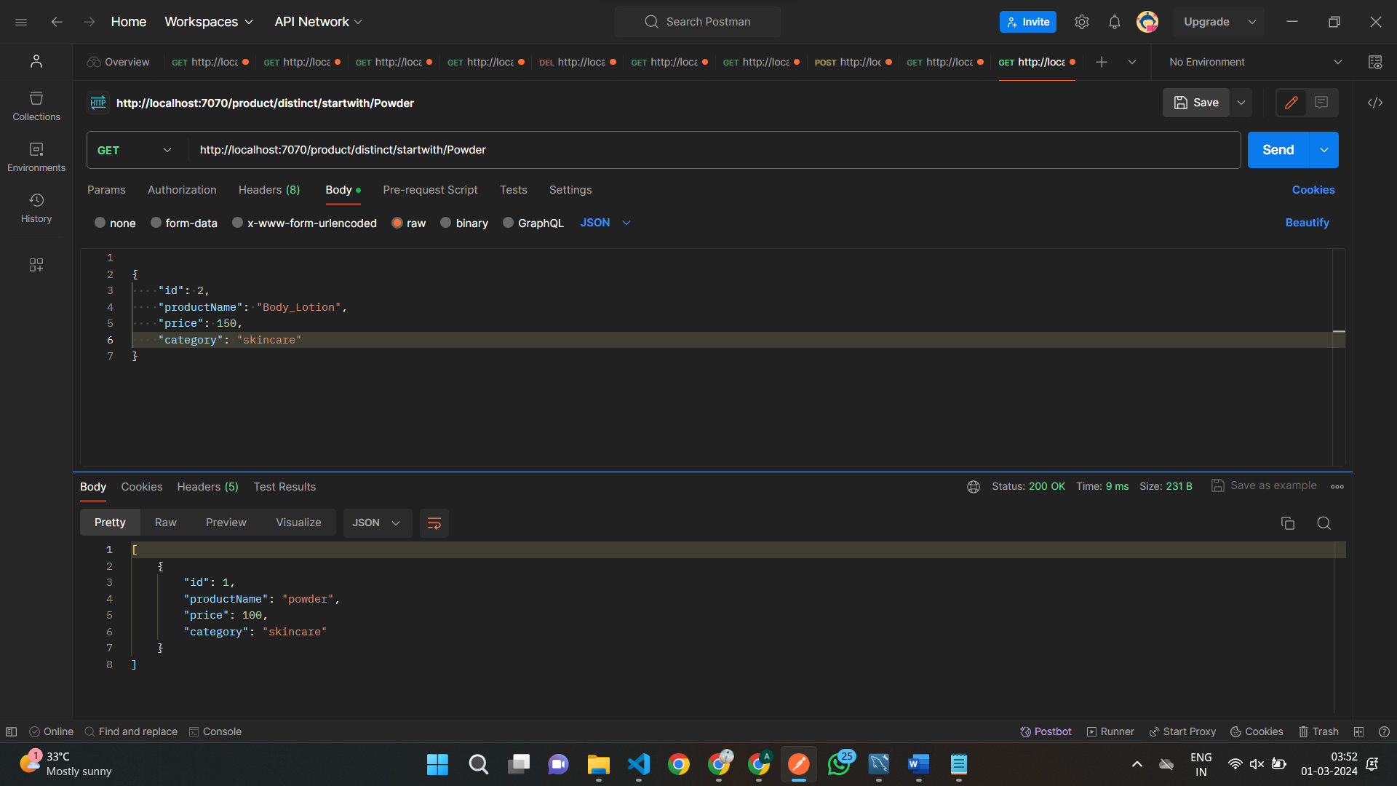

**Get mapping ends with name**

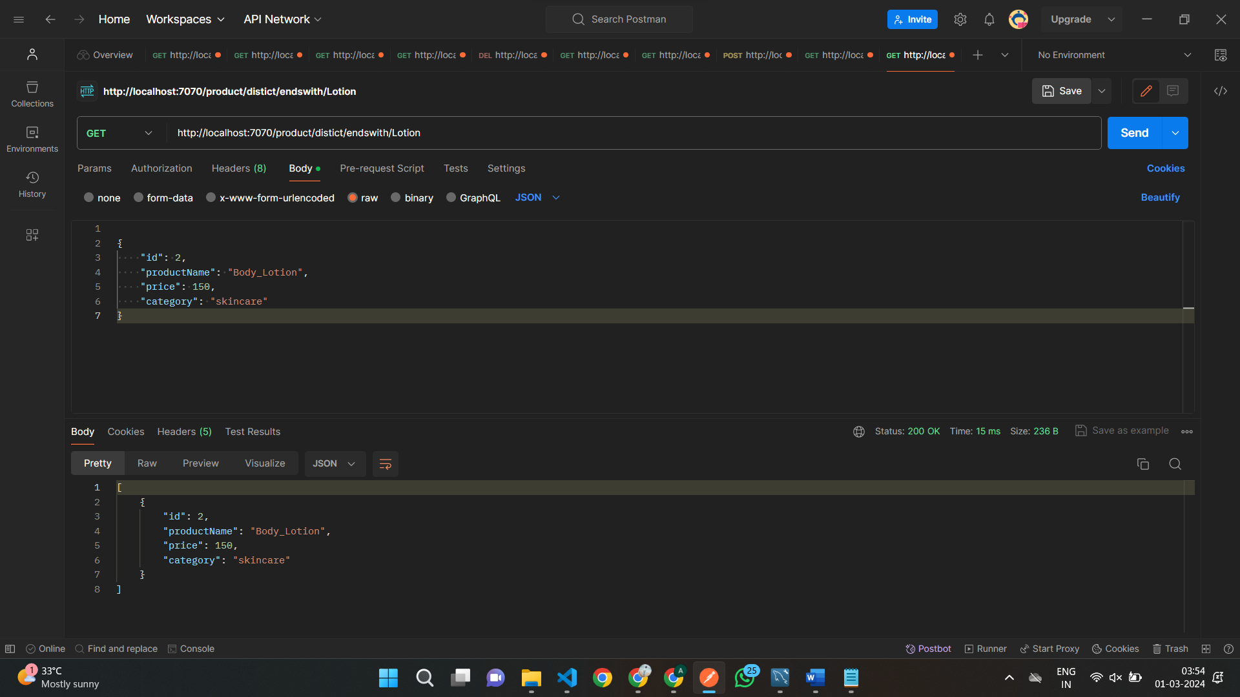

**Get mapping by price**

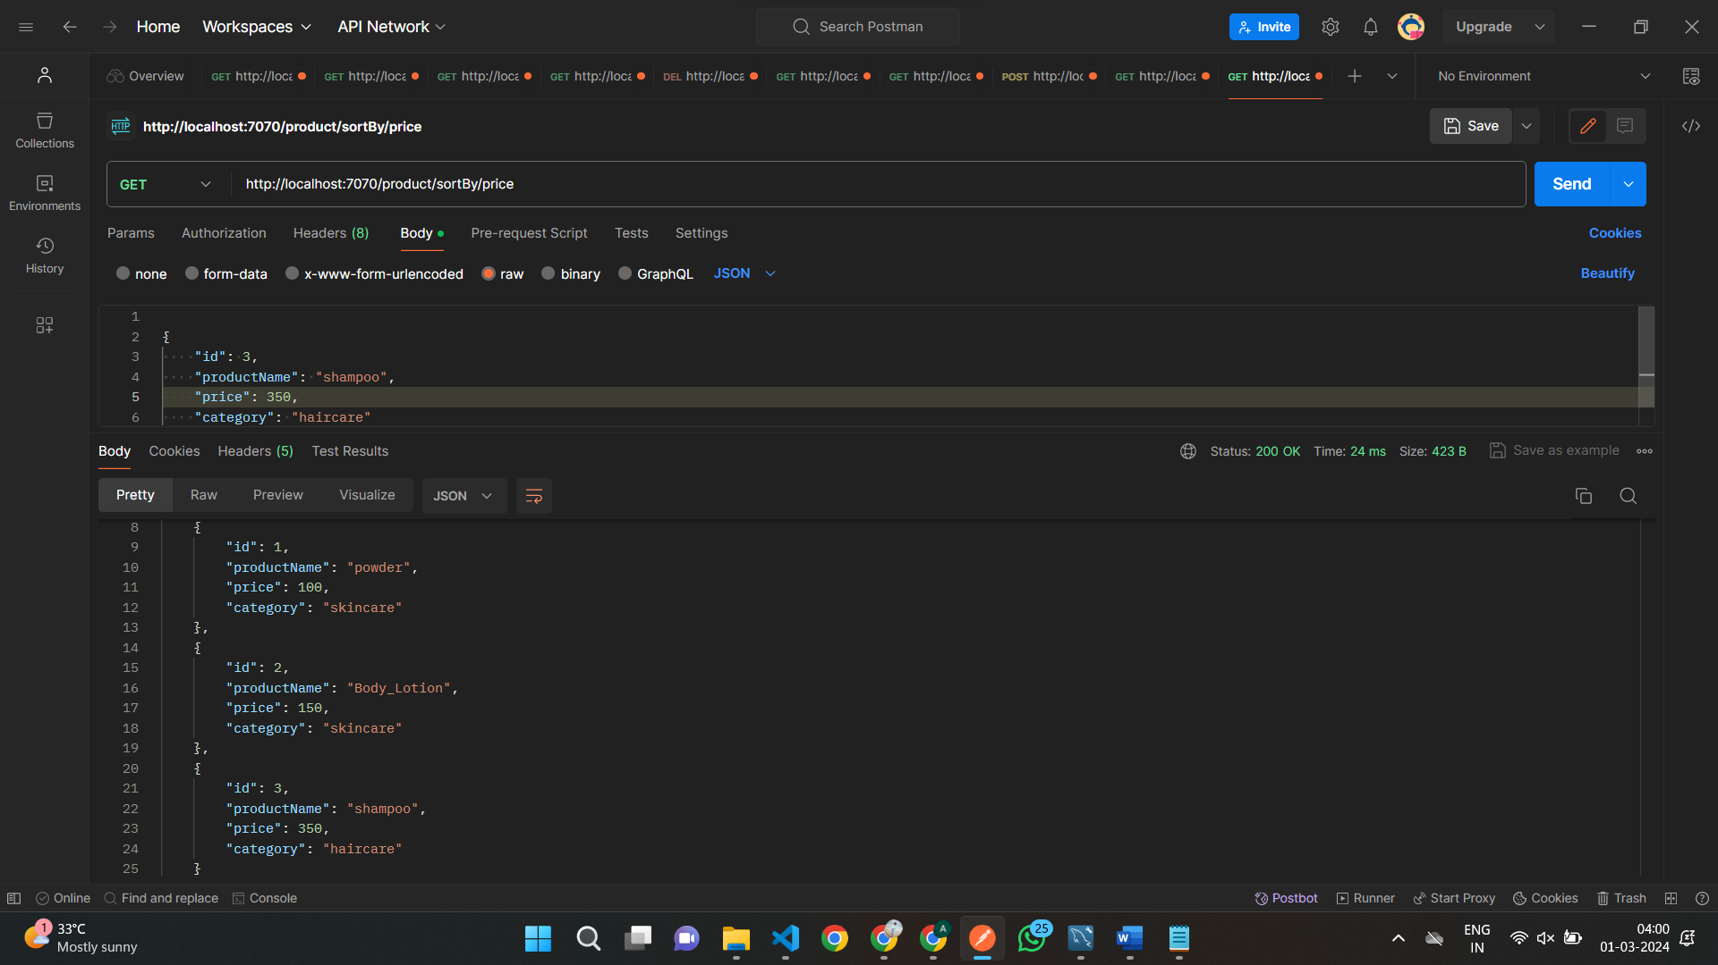

**EXERCISE 3**

**Post mapping**

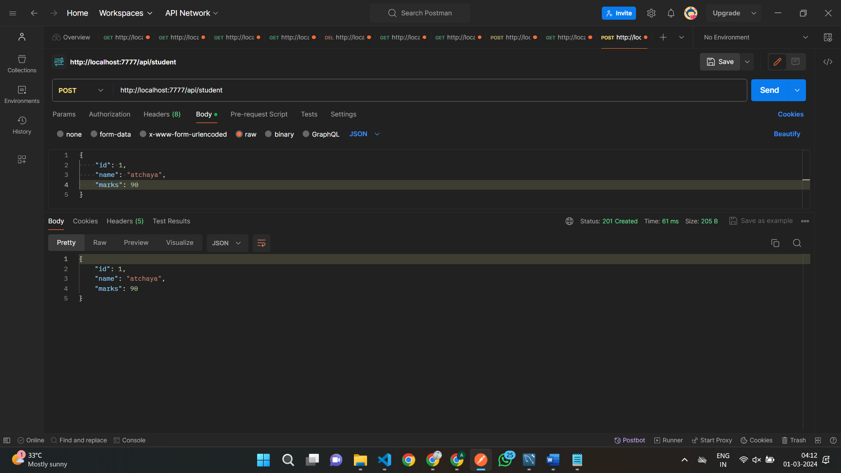

**Get mapping by marks greater than 80**

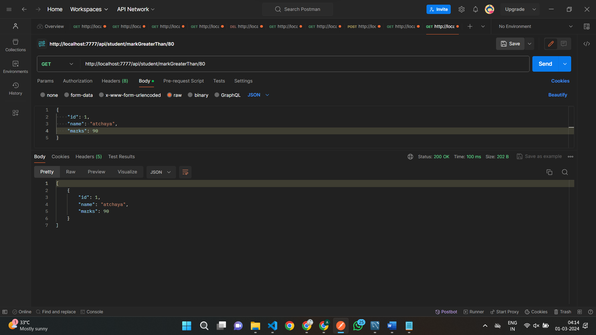

**Get mapping by lesser than 60**

